Comments:
TASK
- New Task-disappear after click
- Hourly rate – option for hourly, days, monthly, fixed
- Related to – Meeting, leads, , ToDo, Mail, Grievance
- Milestone is not reflecting while creating task. It must be link to milestone as mandatory. Sequence Overview – Milestone – Task – Gantt –
- Milestone is not editable
- Milestone Form – copy old one
- By default hide option for all rates.
- Kanban/grid view of task
- Invite member to task
- Earn points: after using this platform
- Download for desktop: mac, window
- Import task from other platform : Trello, Monday, asana, jira, clickup etc.
- https://www.rock.so/help/import-from-whatsapp
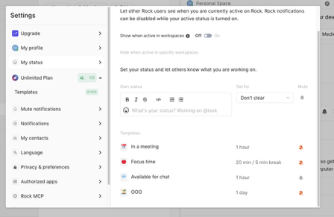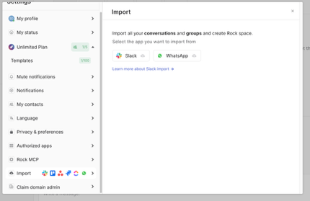
Ref image
DISCUSSION SECTION:
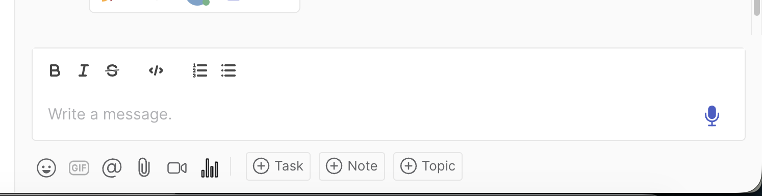
Ref. image
- Option for Voice, Video call, create poll, attachment, emoji
- Schedule message

PRIVACY - Ref. Rock
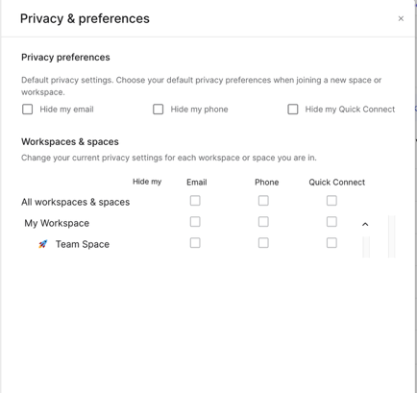
- Option to hide email

Connect thru MCP: Ref. Rock
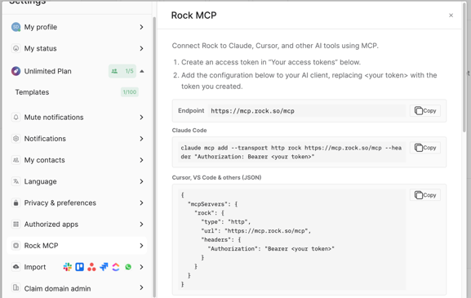

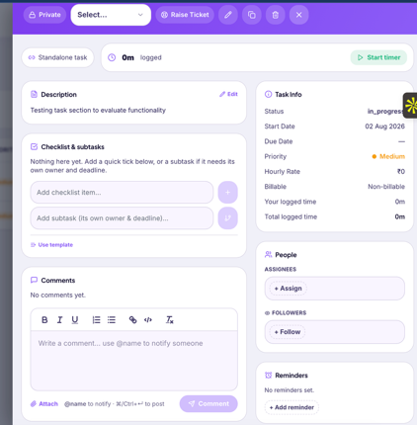
- No option for – sub task, adding vendor, Third party vendor
- Instead of right side pop up, use complete screen to show task panel

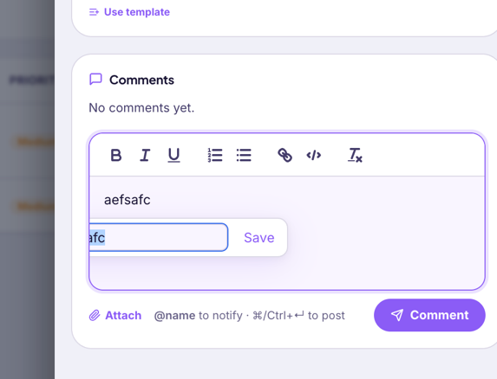
Make it proper and no all options of notepad

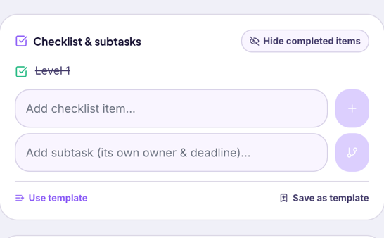
- No progress in % for checklist completion – this should link with main task % progress
- Assign user/vendor/TPV for checklist
- Task Delete-a) recovery option from trash, b) type delete to delete and it should reflect where all it links
PROJECT
- Export Project Data
- Milestone vs task progress
- Expenses
- Timesheet hours
- Copy project – follow older one rules
- Missing – Contract, Expenses, Purchase, Vendor, TPV section, Setting (Core)
- SETTING-
PROJECT SETTING (WHILE CREATING PROJECT)
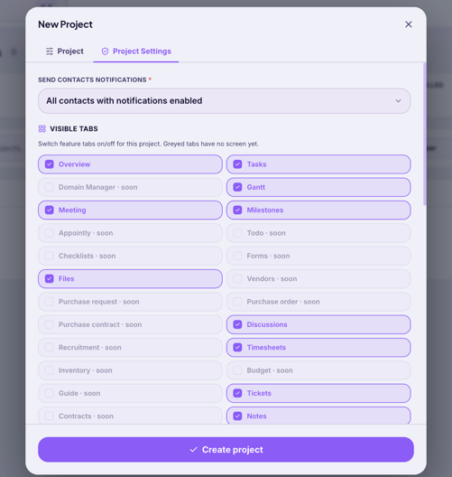
- Separate setting tabs for vendor, TPV relevant to them
MEETING:
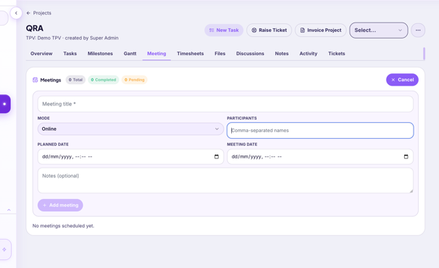
- Meeting should match with input- Contact Harshal
TIMESHEET:
- Auto timer calculation based on usage
FILES
- Follow old one – contact Harshal
- Access file from same panel like below ref.
- 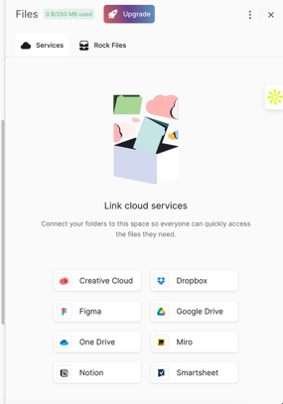
NOTES:
- Option – Edit, Reminder, assign, print, search, Attachment, Count (25/50/100.. ref. older one)
- Notepad style while creating any task
- Task List view – organize and presentable. Ref. older one (it must be better than old one)
- Export option (excel, cs, pdf)
TICKET:
- Ticket should reflect in same project section after creating any ticket
- Ticket table – add “S.N, tkt no, priority, dept, assigned, status” column to represent
- Automated email on every response or update?
- Public ticket form link?
- Add “last reply” date & time in all ticket table, count no., bulk action, view public link of individual ticket, project, merge ticket, services, reminder, task, other tickets, CC, insert predefined replyref. older one
- 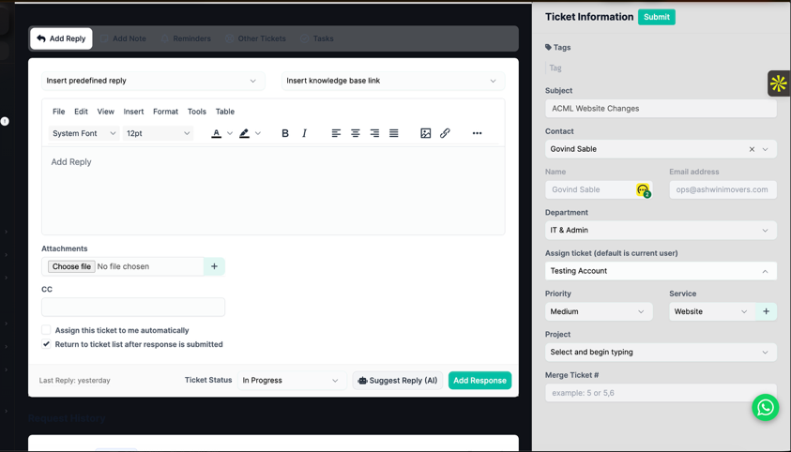

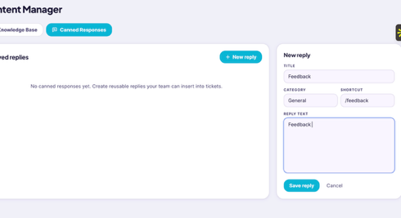
- Reply text area: notepad style
- Ticket reply should have an option to save as “Canned” or convert in KB

- KB Dashboard:
  - Missing: dashboard, create ticket,

